Investigating why large ships float and keys sink?
Experiment 2: Density of Objects
Will it Sink or Float?

Objective: To investigate objects that are more dense than others and determine whether they will sink or float.

Question: What is density and how does density of an object effect if an items sinks or floats?

Materials you will need:

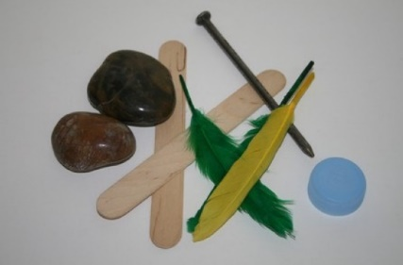
A collection of objects and materials that are different shapes and sizes and density such as:

- Something solid – rock
- Something wooden – pencil or a stick
- Something plastic – spoon, bottle top
- Something metal – nail, key, coins, bolt or a screw
- Other items may include a feather, sponge, material cloth

Instructions:

- Observe and list each object – what is the density of each of the items?
- Predict if the object will sink or float
- Place each object into the large basin of water
- Analyse which items sink and which items float
- Record the outcome and interpret the results

Worksheet 2 / Results: Density of objects
Will it Sink or Float?

Objective: To investigate objects that are more dense than others and determine whether they will sink or float.

Question: What is density? How does density of an object effect if an items sinks or floats?

List the items that you have selected to test in the boxes below.
How dense is each time
What are your predictions – will it sink or float?

My items selected and predictions

____________________________________________________________
____________________________________________________________
____________________________________________________________
____________________________________________________________

Investigate whether each of the objects sink or float in the water in the container.
Sort and classify the objects and record in the boxes below which objects sunk or floated.
Items that Float
Items that Sink

_________________________________
_________________________________
_________________________________
_________________________________
_________________________________

_________________________________
_________________________________
_________________________________
_________________________________
_________________________________

Analyse and interpret your results. Explain what density is? How did the density of the objects caused items to sink or float?
Conclusion of Experiment 2.

Draw pictures or provide photograph’s of your demonstration

